Pakistan

1: Pakistan;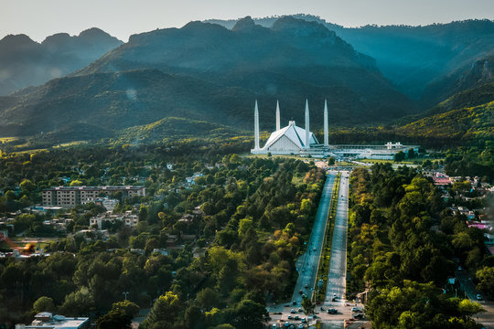

Pakistan is located in Asia. People of Pakistan like music, dance, and yummy food like biryani and kababs.

Pakistan is between the India and Afghanistan, which affects its politics. It is also fighting against terrorism. Pakistan is trying to make things better, like roads and schools. But there are still problems like corruption and not enough stability.

Pakistan is also trying to improve the healthcare of people. They work hard and support each other through tough times. Regardless of difficulties, Pakistan remains a place of warmth, hospitality, and flexibility.

* 1. Punjab; 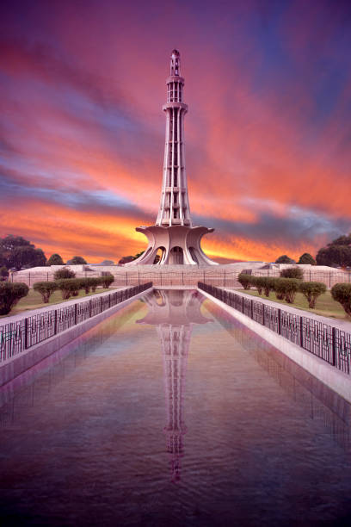

The province forms the bulk of the transnational [Punjab region](https://en.wikipedia.org/wiki/Punjab), divided in 1947 among Pakistan and India.[[7]](https://en.wikipedia.org/wiki/Punjab,_Pakistan#cite_note-8) The provincial capital is Lahore — a cultural and cosmopolitan centre of Pakistan. Punjab is also the world's fifth-most populous subnational entity, and the most populous outside of [China](https://en.wikipedia.org/wiki/China) and India.

* 1. Sindh;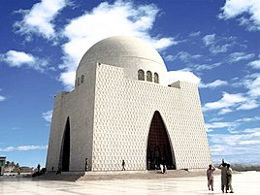

Sindh is the province of Pakistan.it is the major province of Pakistan it plays an important part in the economics of Pakistan. The bog city which is located in Sindh is Karachi which is the big city of Pakistan by population Karachi population is approximately which is reach in 2024 is almost 179,469,000.

1.3Balochistan;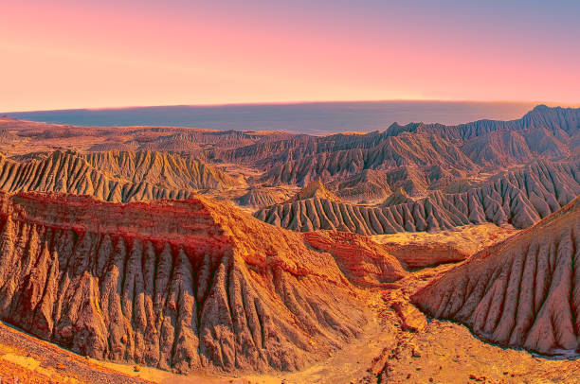

Balochistan is located on the south-eastern part of the Iranian plateau. It borders the geopolitical regions of the Middle East and Southwest Asia, Central Asia and South Asia. Balochistan lies at the mouth of the [Strait of Hormuz](https://en.wikipedia.org/wiki/Strait_of_Hormuz) and provides the shortest.

route from seaports to Central Asia. Its geographical location has placed the otherwise desolate region in the scope of competing for global interests for all of recorded history.

* 1. Khyber Pakhtunkhwa;

The Khyber Pakhtunkhwa, which was previously referred to as the Northwest Frontier Province, is bordered by Azad Kashmir to the northeast and east, to the west and north by Afghanistan, to the southwest by Balochistan, and to the southeast by Punjab. Areas on the western border with Afghanistan are tribal areas administered by the federal government. The provincial capital is Peshawar. The province occupies an area of about 28,773 square miles and is home to a population of about 21,392,000 (2006 est.)

**The Kashmir Dispute;**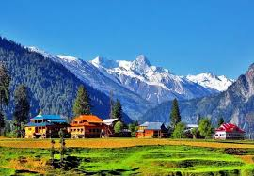

The control of the Kashmir region which is found on the western Himalayas has been the source of conflict between India, Pakistan, and China who all control parts of the territory. The Azad Kashmir region which is part of the territory that is administered by Pakistan is considered as Independent territory despite the Pakistani control with Muzaffarabad as the capital. The rest of the territory that is administered by Pakistan is comprised of Baltistan and Gilgit.

|  |  |  |
| --- | --- | --- |
| Provinces | Capital | Area |
| Punjab | Lahore | 205,344 km |
| Sindh | Karachi | 140,944 km |
| Balochistan | Quetta | 347,190 |
| Khyber Pakhtunkhwa | Peshawar | 74.521 km |